A163, A166-Asia-BMAC-Figurine, Bronze Age, 2300–1700 BCE 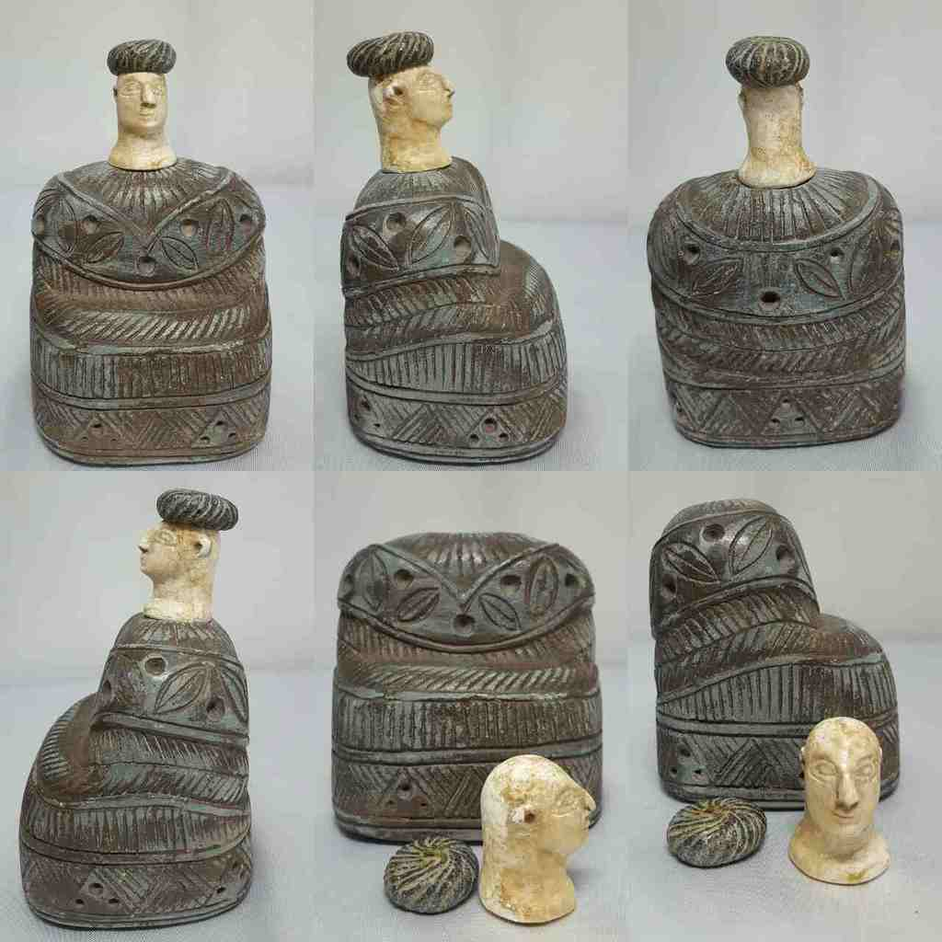

Figs. 1-6. BMAC-Figurine, Bronze Age, 2300–1700 BCE-14 x 10 cm

Case no.: 2

Accession Number: A163, A166 (cap); A 156, A57, A162, A1100, A1107, A1127

Formal Label: BMAC-Figurine, Bronze Age, 2300–1700 BCE

**Display Description**

This sculpture is from the region of Ancient Balkh, Bactria (Afghanistan), of the Bronze Age Bactria-Margiana Archaeological Complex (BMAC), formerly the Oxus Civilization, w Central Asia, ca 2300–1700 BCE. It depicts a seated female wrapped in a *kaunakes*, the traditional Bronze Age Mesopotamian dress. *Kaunakes* were originally composed of long stacked tuffs of sheepskin or goatskin, (sculpted here in dark green clinochlore, an aluminosilicate of iron and magnesium), the texture of which is rendered by a series of chevrons and vertical, diagonal, curvilinear and parallel lines. Clinochlore is also used for the turban which is decorated in radiating curvilinear lines suggestive of a sheepskin or goatskin. The head is sculpted from white calcite.

These anthropomorphic statuaries may represent the pre-eminent goddess, who, in the mythology of w Central Asia, plays a regulatory role in the order of nature, controlling the wild forces symbolized by lions, serpents or dragons (Mattet and Amiet 2008: 282-283). This deity is also identifiable in glyptic (carving or engraving) sources, but its identity is more ambiguous in statuary, where it can also represent aristocrats.

**LC Classification:** GN778.32.A4

Date or Time Horizon: Middle to Late Bronze Age, 2300–1700 BCE

Geographical Area: between Balkh, Afghanistan, and Merv, Turkmenistan

**Map, GPS coordinates:** Bactria (Balkh), Afghanistan,36.767791 66.900265; Merv [Erk Kala], Turkmenistan. 37.669606; 62.192567.

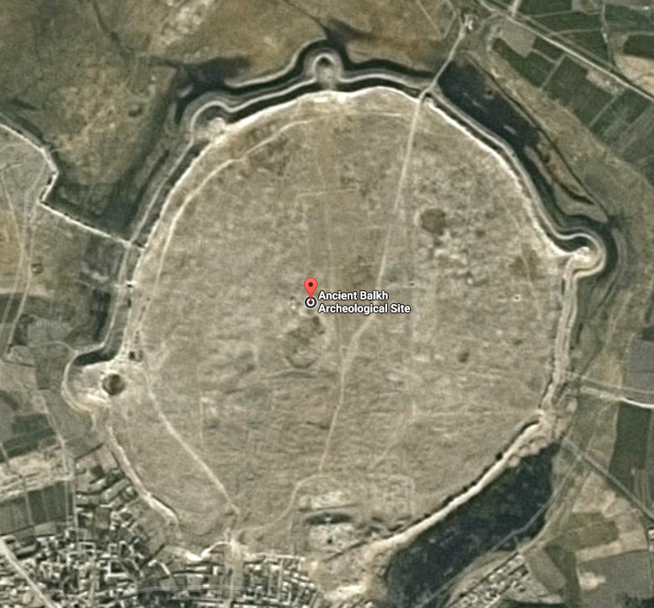 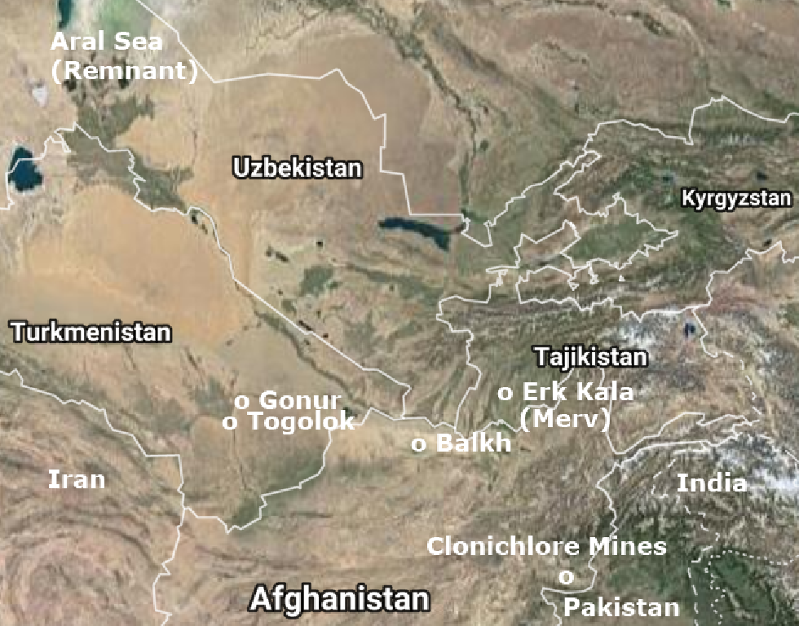

Fig. 1. Ancient Balkh, Bactria (Afghanistan), 36.767791 66.900265; Fig. 2. Map of the intersection (clockwise) of Afghanistan, Pakistan, India, Tajikistan, Kyrgystan, Uzbekistan, Turkmenistan and Iran. After Google.

Cultural Affiliation: Bactria-Margiana Archaeological Complex (BMAC), formerly Oxus Civilization

Media: composite; chlorite body and turban and white calcite head.

Dimensions: H 14 cm x W 10 cm

Weight: 2.0 lb; 907.185 gm

Provenance: Private collection, vintage intaglio, Thailand

**Discussion:** Representational sculpture in w Central Asia in the Middle Bronze Age is rare. This highly stylized, sculpture above is a composite with green clinochlore for the body and turban and chlorite for the head. The nearest source of clinochlore is Khogyani District, Nangarhar Province, Afghanistan (4° N, 70° E, est.; MinDat, clinochlore). The most ancient form of the woolen mantle, so woven as to imitate the locks of a sheep’s fleece, was worn originally by men as a skirt from the waist and by priests and women draped from the left shoulder as the Ur-Nanshe votive shows (Figs. 7-8).

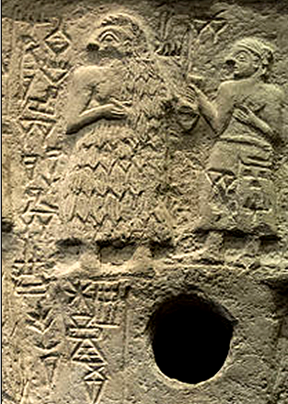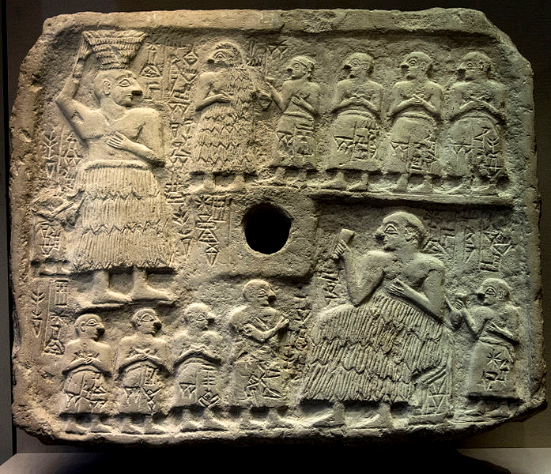

Fig. 7. Detail of a shamanic, therianthropic priest from Ur-Nanshe votive relief. Fig. 8, king of Lagash, Sumeria, limestone votive relief Early Dynastic of Sumer IIIa (2550–2500 BCE). Excavated at Tello, ancient Girsu, 1888 (Parrot 1948:91). Height: 39 cm (15.4 in). Width: 46.5 cm (18.3 in). Depth: 6.5 cm (2.6 in). Musée du Louvre. Acc. No. AO 2344 [File:2015-12-Relief votif d Ur-Nanshe roi de Lagaslr.jpg](https://commons.wikimedia.org/w/index.php?title=File:2015-12-Relief_votif_d_Ur-Nanshe_roi_de_Lagaslr.jpg&redirect=no)

Ur-Nanshe’s role as king was as protector (denoted by his large size) and builder (denoted by the hod of bricks he carries) of the foundations of society expressed in Sumerian: "Ur-Nanshe, king of Lagash, son of Gunidu, built the temple of Ningirsu; he built the temple of Nanshe; he built Apsubanda." In register two he offers a libration to all that helped in building the foundation of the temple and the society. It also mentions essential Sumerian trade: "boats from the land of Dilmun [in the Persian Gulf] carried the wood [for him]." This is the first mention of Bahrain (Dilmun) in history. The kaunakès garment Ur-Nancshe wears was believed to possess magical powers that may have devolved from the practice of wearing the skins of animals as therianthropes and as practiced by shamans to assume the wisdom of selected animals and shamanic hunters to lure their prey. In this spiritual regard, it was worn by gods (Delaporte (1909: nos. 131-133) and goddesses, their priests and priestesses, and deified kings (Delaporte 1909: nos. 119, 120) and queens.

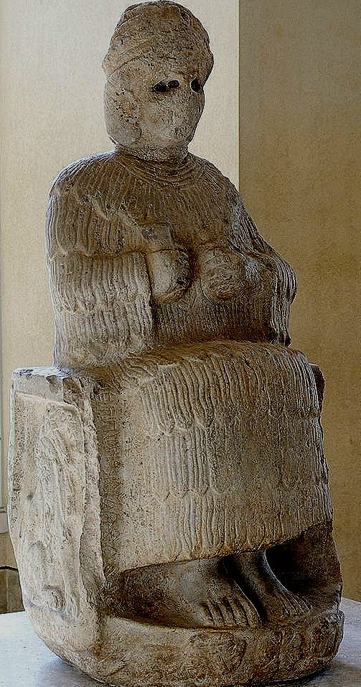 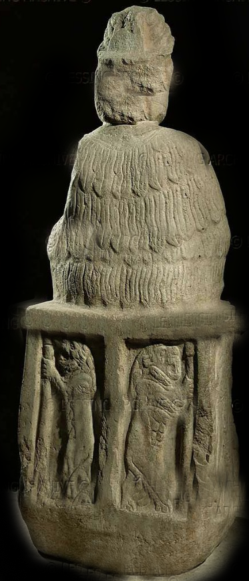 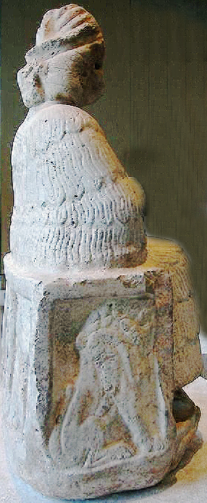 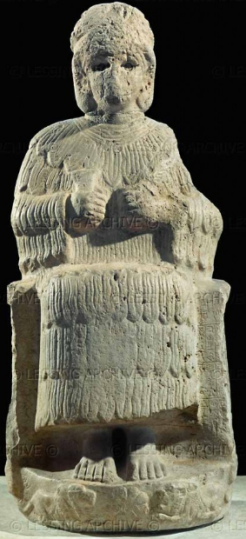 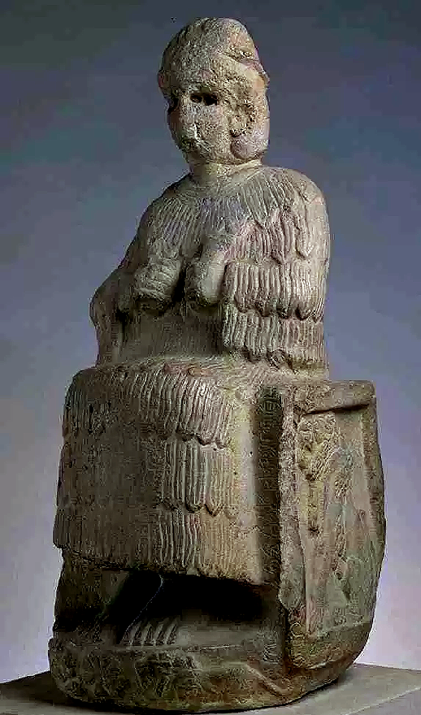

Figs. 9-13. Limestone statue of the goddess Narundi dedicated by Puzur-Inshushinak, King of Susa, Prince of Anshan, ca 2100 BCE, excavated by Jacques de Morgan, from a podium in a sanctuary on the acropolis at Susa 1904-1907 (Amiet 1988: 70-71). After https://de.wikipedia.org/wiki/Datei:Statue_Narundi_Louvre_Sb54-Sb6617.jpg; Marie-Lan Nguyen, 2009. Musée du Louvre.

Narundi is wearing the kaunakès denoting her goddess stature. The statue has two inscriptions: one in Akkadian giving the name of the donor, "Puzur-Inshushinak, prince of Awan;" the other in Elamite, the local language, giving the name of the goddess, “Narundi”. Her headdress with three pairs of horns was an attribute of Sumerian gods of high rank as was her kaunakès. She is seated at a ritual libation event and holds a goblet denoting fruitfulness of the land in her right hand and a palm frond in her left hand denoting her desire for peace. However, her version of peace is backed up by two snarling lions (symbols of Ishtar, goddess of war) on either side of her throne and supporting her throne on the back, but this Ishtar impulse is kept in check as is signified by the two lions beneath her feet.

The source of *kaunakès* can be traced to the Indo-Europeans, the ethnolinguistic background for the BMAC figurines of this type. From the Sumerian, a language isolate, *gú-èn* diffused to Persia (\**gaunàka*) to Greece (*s*) to the Latin-speaking world (*gaunacum*), to the Indo-Aryan world (*gonàka*) and finally to the Slavic world, which form we have today, *kaunakès* (Przyluski 1931: 347; Heuzey 1887; Sarzec 1884: 168, pl. 2 and fig. 1). The Semites made loan words of the Semitic Babylonian *gú-anna* (as *guannakku*) and the Sumerian language isolate *gú-èn* as (*guennakku*), but in either case the origin of the word was not Semitic but Indo-European (Langdon 1920: 326-329).

In order to understand how these various statuettes and figures played a role in BMAC and Indo-European society, it is revealing to examine some of the scenes in which these figures play a ritualistic role. Perhaps among the most revealing is the silver pyxis in the Musée du Louvre.

 

Figs. 14-15. Silver Pyxis, AO 31881, Louvre Museum, acquired 2001. After <https://image.slidesharecdn.com/tosicambridgeshahdadfinal-140921080852-phpapp01/95/shahdad-shahri-sokhta-tepe-yahya-many-sites-for-a-single-history-91-638.jpg?cb=1411290523>

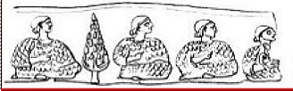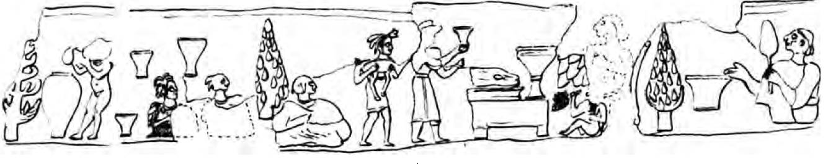

1 2 3 4 5 6 7 8 9 10 11 12 13 14 15 16 17 18 19 20 21 22

Fig. 16. Glyptic scene on the Silver Pyxis in the Louvre Museum.

1. Beardless, seated figures with smoothe head-coverings with hair visible only at back wich is similar to the head-coverings of BMAC figurines. They are facing right, dressed in *kaunakès*, with right arms protruding
2. Grape bearing vines.
3. Same as 1.
4. Same as 1.
5. Same as 1.
6. Grape-bearing vines that have been harvested.
7. Amphora being filled with symbolic fluid, water or wine.
8. Nude servant about to dip a single-handed flagon into an amphora.
9. Three flagons tha the servant has filled.
10. Seated figure (smaller than nos. 1, 3, 4, 5) with tuffs of sheepskin or goatskin protruding from on headdress, facing right, dressed in a *kaunakè*, [with right arm protruding].
11. Same as 10.
12. Grape-bearing vines.
13. Same as nos. 1, 3, 4, 5, but smaller.
14. Servant with feather headdress and three-petalled lily protruding in front carrying a sacrificial kid and being led by a priest to the sacrifical table.
15. Priest about to sprinkle consecrated wine on the already slaughtered kid on the butcher block table.
16. Slaughtered kid on butcher block table.
17. Communal flagon containing wine (?), symbolic of the sacrificial blood of the kid.
18. Servant pressing and presenting harvested grapes for the communal flagon.
19. Deity looking on the sacrificial kid.
20. Grape-bearing vines.
21. Communal flagon.
22. Seated priest (deity?) with same headdress as nos. 1, 3, 4, 5, holding a palm leaf in the left hand (signifying peace?) and consecrating the contents (wine or blood of the kid?) of a flat bottomed vessel with the right hand.

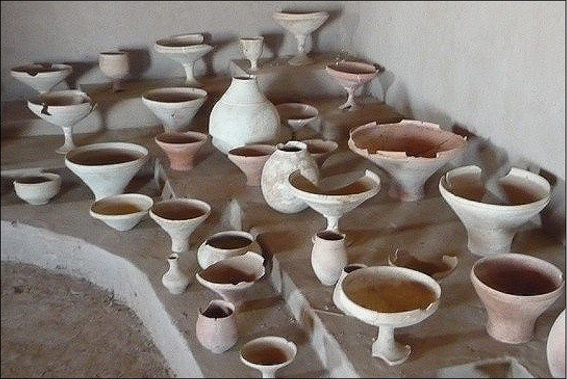

Fig. 17. A series of ceramic chalices, flagons, communal libation vessels and flat-bottomed vessels from the huge necropolis of Gonur illustrating the shape of the vessels in the libation scenes in the various images given. From http://www.centralasia-adventures.com/image/cache/data/info/turkmenistan/margush/11-800x600.jpg.

Below is another example of a ritual scene is the “Libation Scene” on a silver vessel, also in the Musée du Louvre.



Fig. 18. After <https://image.slidesharecdn.com/tosicambridgeshahdadfinal-140921080852-phpapp01/95/shahdad-shahri-sokhta-tepe-yahya-many-sites-for-a-single-history-94-638.jpg?cb=1411290523>

 

Figs. 19-20. “Libation Scene” on the silver vessel, Musée du Louvre. After Amiet 1977, Fig. 13, pl 3. See also Hinz 1969, pl 5.

Figs. 18-20 feature a silver cup with two registers. Bottom register: agricultural workers, three bearded men with kilts, two plowing one sowing seed, and two naked boys, one with two oxen, the other with two cattle plowing a field. In all of the Indo-European statuettes from the BMAC area all male individuals do not have beards or long hair. This norm seem to be violated here. Top register, three bearded men, seated, in three scenes. Scene one: Two men, one in a *kaunakè* one in a textile wrap (marked by horizontal cross-hatching), talking and gesticulating with one arm held up to the other, one man making an account on a table. Scene two: two men one in a *kaunakè* one in a textile wrap, looking to the right. Scene three: three bearded men, one with *kaunakè* holding a sheaf (of accounts?), two men in textile wraps, between them two flagons above a basket of grape clusters, one gesticulating with one arm held up to the other and the other drinking from a goblet. In the lower register are scenes of plowing and sowing seeds by figures with textile kilts.

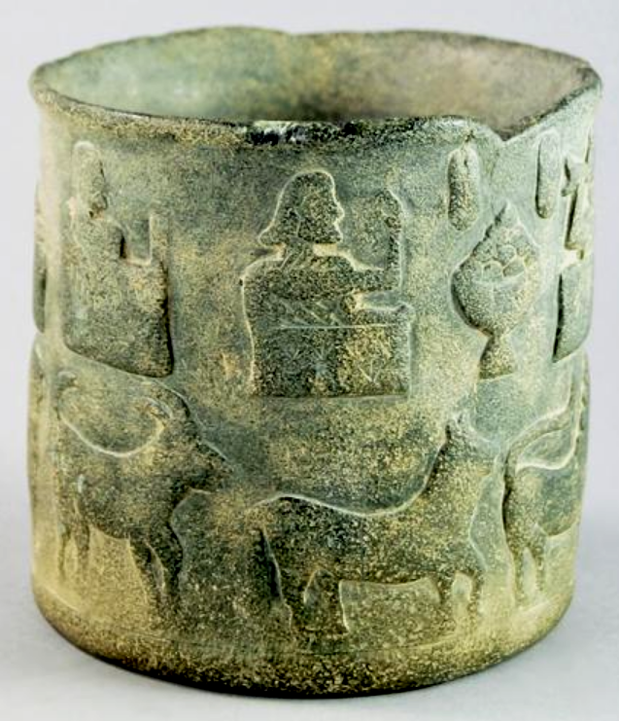

Fig. 21. This clinochlore BMAC vessel shows a register of seated individuals, holding flagons, with bunches of grapes suspended from above as if from a trellis with a bowl filled with clusters of grapes below. The participants are all seated and all wear *kaunakès*. In all of the Indo-European statuettes from the BMAC area all male individuals do not have beards or long hair. This norm seem to be violated here again. Below them is a register of trained, domesticated sheep and cattle marching in order. From Roseberys 70/76 Knights Hill London SE27 0JD United Kingdom, Lot 1349 of 1116, Sept. 2014. 13cm high. After <https://auctions.roseberys.co.uk/images/lot/1654/16548_8.jpg>

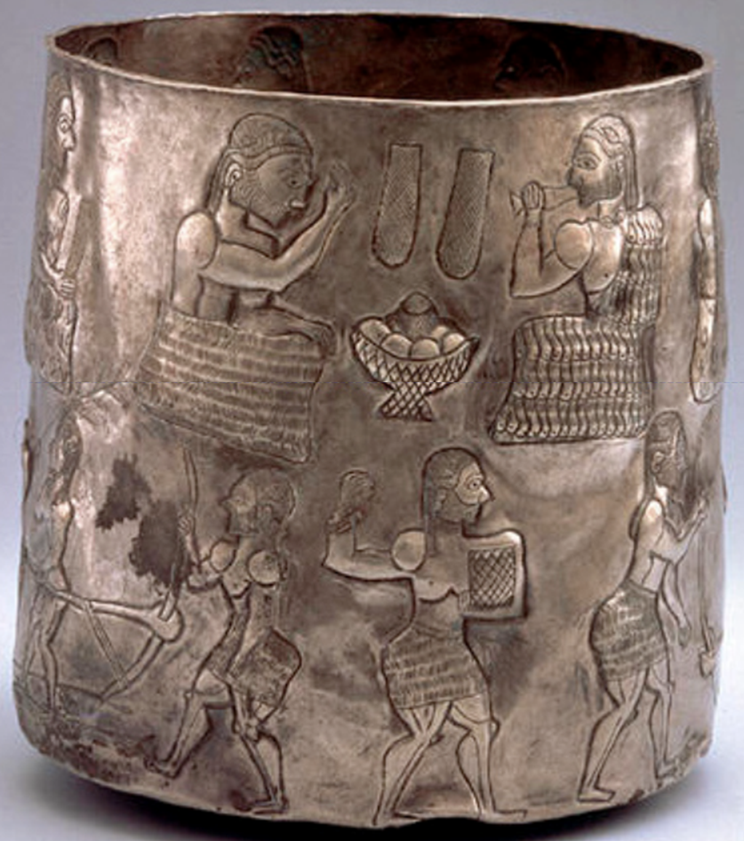

Fig. 22. Bactrian Silver Cylindrical Cup, Late 3rd-early 2nd millennium BCE (H 12.6 cm) with Agricultural and Ceremonial Scene after https://encrypted-tbn1.gstatic.com

## 

During the Bronze Age in late 3-early 2nd millennium BCE gold and silver vessels with elaborate figural scenes were executed in low relief with incised details. These details that seem to be at variance with the non-bearded, *kanaukè*-wearing Indo-Europeans involved in ritualistic scenes so far. Once again, a good example of this discrepancy is Fig. 19, featuring seven bearded and mustached male banqueters seated in a row above a register of bearded men and boys plowing a field. In all of the Indo-European statuettes from the BMAC area all male individuals do not have beards or long hair. This norm seem to be violated here. The figures in the upper row, are facing two bunches of grapes and a cross-hatched communal dish (indicating clinochlore?) filled with fruit (stylized grape clusters?) The figure on the right also wears a necklace and a beaded bracelet. He also wears his *kaunakè* covering his left arm, perhaps signifying his élite (priestly?) status. The figure on the left wears a textile mantle with rows of cross-hatching, which is worn by all the workers in the lower register. By this time the wearing of the true *kaunakè* was reserved for the élite. Not seen in this view are five other seated male figures, their garments and rôles are distinguished by those wearing *kaunakès* or textile mantles



Fig. 23. Seated, beardless figure with a tight-fitting cap, hair gathered at back, both hands exposed wearing a full *kaunakè* from Togolok 21.

Togolok-1, Togolok-21 were temples associated with fire worship and libation rituals and Gonur was a huge necropolis. As we have seen in the preceding examples grapes were used in the preparation of libation drinks for participants. While this was probably part of a common Indo-Iranian custom and not specific to Zoroastrianism (Dandamaev 1989: 170; there was a drink called haoma in Indo-Iranian religion that to which this custom may have been preparatory (Frye 1996: 68). As Victor Sariniandi has stated. “If Togolok was a temple connected with cultic libations and a fire cult, we can assume a connection with the milieu from which Zoroastrianism might have sprung. However, these elements so important in Zoroastrianism do not permit us to view this structure as a true Zoroastrian temple, for nowhere in the Avesta is there a mention of temples. The observance of cultic rituals in temples seems to have been a feature of the religious life of the inhabitants of both Margiana and Bactria, who were largely related and shared a similar culture and religious beliefs (Sariniandi 1992)” The use of the term "proto-Zoroastrian" by Sariniandi came under criticism, because Zoroaster’s life and home region are unknown, but, J. Choksy has expressed a confirming note in his assessment of the ritual room at Togolok-21 as "a pre-Zoroastrian or even a very early Zoroastrian" fire temple (Choksy 2007: 261). In s Bactria at a temple at Dashley-3, room 2, which is distinctly a fire temple with a raised brick hearth, it repeats the architecture of raised podia of Togolok-21 rooms 8 and 36.

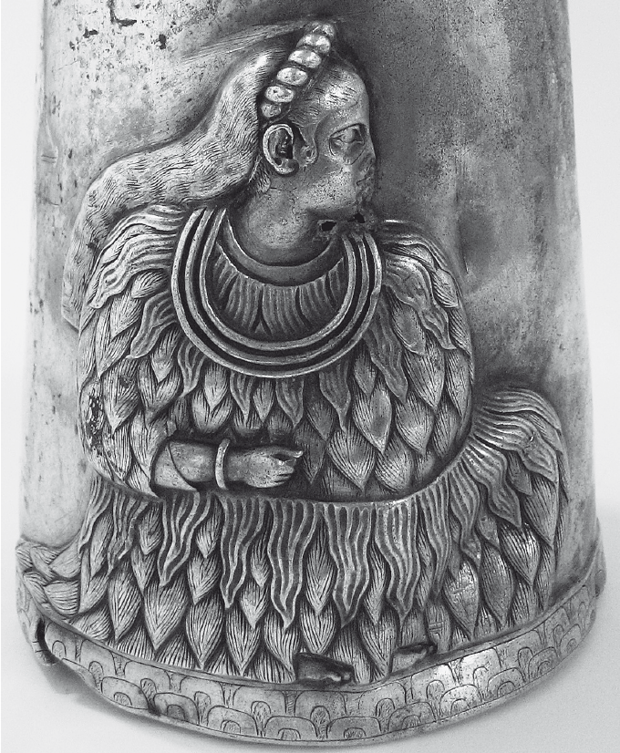

Figs. 24-25. This Elamite image of a highly empowered woman or goddess from Persepolis on a silver flagon of the 3rd millennium is dressed in a full *kaunakè* with full braid of hair at the back and a three strand gold necklace. From https://s-media-cache-ak0.pinimg.com/236x/e3/fd/d2/e3fdd212a99007ac7d3c3c948b75fe89.jpg

The silver flagon in Figs. 24-25 is also inscribed with a proto-Elamite script, the text of which lists the name of Narunde, the sister of the goddess of the goddess of war and fertility, Ishtar, and it is possible that the present sculpture is another image of Narunde.

**References:**

Amiet, Pierre. 1978. “Antiquités de Bactriane,” *Révue du Louvre* 28: 153-164.

Amiet Pierre. 1977. *L'Art antique du Proche-Orient*. Paris: Mazenod, 1977, pl. 44, fig. 324, p. 368.

Amiet, Pierre. 1977. “Bactriane proto-historique,” *Syria* 54: 89-121.

Amiet, Pierre. 1988. Suse: 6000 ans d'histoire. Paris: Musée du Louvre, Editions de la Reunion des musées nationaux.

Choksy, J. K. 2007. “Reassessing the Material Contexts of Ritual Fires in Ancient Iran,”

*Iranica Antiqua*, 42: 229-69.

Delaporte, Louis. 1909. *Catalogue du Musée Guimet: cylindres orientaux*. Paris: E. Leroux.

Frye, Richard Nelson. 1996. [*The heritage of Central Asia: from antiquity to the Turkish expansion*](http://www.worldcat.org/title/heritage-of-central-asia-from-antiquity-to-the-turkish-expansion/oclc/909044889&referer=brief_results)***.*** Princeton: Weiner.

Heuzey, Léon. 1887. “Une étoffe chaldéenne (le kaunekeès),” *Revue Archéologique*, Troisième Série, 9 (Janvier-Juin): 257-272.

Hinz, Walther. 1969. “Eine neu gefundene Altelamische Silbervase.” In Walther Hinz; Rykle Borger; Gerd Gropp, eds., *Altiranische Funde und Forschungen*. Berlin: Walter de Gruyter, pp. 11-44.

Huot Jean-Louis. 1989. *Les Sumériens, entre le Tigre et l'Euphrate*. Paris: Errance.

Mattet, Laurence and Pierre Amiet. 2008. [*Le profane et le divin: arts de l'antiquité, de l'Europe au sud-est asiatique : fleurons du musée Barbier-Mueller*](http://www.worldcat.org/title/profane-et-le-divin-arts-de-lantiquite-de-leurope-au-sud-est-asiatique-fleurons-du-musee-barbier-mueller/oclc/298112421&referer=brief_results). Paris: Hazan; Genève: Musée Barbier-Mueller.

MinDat (clinochlore). <https://www.mindat.org/loc-188777.html>).

Langdon, Stephen. 1920. “Kaunekés*The Journal of the Royal Asiatic Society of Great Britain and Ireland*, No. 2 (Apr.), pp. 326-329.

Parrot, André. 1948. *Tello, vingt campagnes de fouille (1877-1933)*. Paris: Albin Michel.1948.

# Pittman, Holly. 1984. ***Art of the Bronze Age: Southeastern Iran, Western Central Asia and the Indus Valley.* New York: Metropolitan Museum of Art.**

Potts, Daniel. 2008. “Puzur-Inšušinak and the Oxus Civilization (BMAC): Reflections on Šimaški and the geo-political landscape of Iran and Central Asia in the Ur III period,” *Zeitschrift für Assyriologie und vorderasiatische Archäologie*, 98(2): 165–194.

Przyluski, Jean. 1931. “Une étoffe orientale, le kaunakes,” *The Journal of the Royal Asiatic Society of Great Britain and Ireland*, No. 2 (Apr.), pp. 339-347.

Sariniandi, Victor I. 1990. “Togolok 21, an Indo-Iranian Temple in the Karakum,” *Bulletin of the Asia Institute*, New Series, 4 (In honor of Richard Nelson Frye: Aspects of Iranian Culture): 159-165.

Sarzec, Édouard de. 1884. *Découvertes en Chaldée*. Paris: Leroux.